Example Project

Design File Template
Version <1.0>
<mm/dd/yyyy>

Revision History
[Provide information on how the development and distribution of the Design Files, up to the final point of approval, was controlled and tracked. Use the table below to provide the version number, the author implementing the version, the date of the version, the name of the person approving the version, the date that particular version was approved, and a brief description of the reason for creating the revised version.]
Version  # | Implemented  By | Revision  Date | Approved  By | Approval  Date | Reason
1.0 | <Author name> | <mm/dd/yy> | <name> | <mm/dd/yy> | Initial Design Definition draft

Table of Contents
1. Product Description 5
1.1 Why is it needed? 5
1.2 What is it made of? 5
1.3 What will it look like? 5
1.4 How long should it take to create? 5
1.5 What are the acceptance criteria? 5
1.6 How will those criteria be met? 5
1.7 Who will make sure the criteria are met? 5
2 Product Functionality 6
2.1 Product goal 6
2.2 Who will use it? 6
2.3 End user consideration of use 6
2.4 Is it clear on how to use it? 6
3 3D Files 7
4 2D Technical Drawings 8
5 Test requirements 9
6 Certification Requirements 9
7 Inspection Pass Criteria 9

Note to the Author

[This document is a template of a Design File document for a project. The template includes instructions to the author, boilerplate text, and fields that should be replaced with the values specific to the project.

- Blue italicized text enclosed in square brackets ([text]) provides instructions to the document author, or describes the intent, assumptions and context for content included in this document.

- Blue italicized text enclosed in angle brackets (<text>) indicates a field that should be replaced with information specific to a particular project.

- Text and tables in black are provided as boilerplate examples of wording and formats that may be used or modified as appropriate to a specific project. These are offered only as suggestions to assist in developing project documents; they are not mandatory formats.

When using this template for your project document, it is recommended that you follow these steps:
- Replace all text enclosed in angle brackets (i.e., <Project Name>) with the correct field values. These angle brackets appear in both the body of the document and in headers and footers. To customize fields in Microsoft Word (which display a gray background when selected):
  - Select File>Properties>Summary and fill in the Title field with the Document Name and the Subject field with the Project Name.
  - Select File>Properties>Custom and fill in the Last Modified, Status, and Version fields with the appropriate information for this document.
  - After you click OK to close the dialog box, update the fields throughout the document with these values by selecting Edit>Select All (or Ctrl-A) and pressing F9. Or you can update an individual field by clicking on it and pressing F9. This must be done separately for Headers and Footers.
- Modify boilerplate text as appropriate to the specific project.
- To add any new sections to the document, ensure that the appropriate header and body text styles are maintained. Styles used for the Section Headings are Heading 1, Heading 2 and Heading 3. Style used for boilerplate text is Body Text.
- To update the Table of Contents, right-click and select “Update field” and choose the option- “Update entire table”
- Before submission of the first draft of this document, delete this “Notes to the Author” page and all instructions to the author, which appear throughout the document as blue italicized text enclosed in square brackets.]

Product Description
The Product Description is a high level overview of what the product is intended to be, it also allows anyone who studies it to obtain an understanding of what is involved in order to produce that product. The Product Description should include the following elements:

Why is it needed?
[Description of why this product or component is needed.]

What is it made of?
[What are the main materials and specify any special requirements the material has to meet.]

What will it look like?
[Describe the general form, shape, and overall appearance of the product.]

How long should it take to create?
[Outline the main milestones within the project plan or indicate desired dates for completion.]

What are the acceptance criteria?
[This should be a description of either the overall acceptance criteria or the component acceptance criteria, bearing in mind this is a top level overview and more details will be provided later in the document.]

How will those criteria be met?
[How are the product to be verified, is it internal testing, specific testing, and regulatory testing?]

Who will make sure the criteria are met?
[Who will verify the product, is it internal testing, specific testing, and regulatory testing?]

Product Functionality
In order to create a product that works, there are questions you should keep in mind about the product you’re designing, who will be using it, and how they’ll be using it. This is important information for the supplier to understand so that they can take into consideration the product functionality during the manufacturing process.

Product goal
[Write the goal of the product.]

Who will use it?
[Who is the product intended for, describe the end user/s.]

End user consideration of use
[Take into consideration the potential uses and how the product may be used for which it was not designed for. Example of this would be the use of a screwdriver which is intended to drive screws; however, the end user may use the screwdriver for alternative functions such as a pry bar, piercing device, stirring device, wedge, improvised hammer, chisel…]

Is it clear on how to use it?
[Describe how the product is intended to be used, are there and special instructions required for the supplier to be aware of?]

3D Files
[The fact that there are so many different software packages available, a common standard for file transfer is generally used:]
[STEP and IGES, of the two, IGES is the older format. It can contain pretty much all of the geometry types, wireframe, dimensions and annotations, surfaces, solids, etc... It is a raw, standardized geometry exchange only. Basically, the data goes in there however the source system does that. The receiving system must parse the file and often deduce what is in there from what is given. Product structure isn't a part of the action, with basic attributes like layers and colors used to differentiate different solid models. Tolerances vary between systems, and this is important to know:]
[STEP files improve on IGES in that tolerance data is included, along with significant amounts of meta-data, including product structure, solid model definitions, etc...]
[There are two variations of STEP. One is geometry based, and the other is product structure based, and they can be used in tandem to communicate very complex designs between complex systems. ]
[STEP geometry files can be monolithic, containing all the product structure info, and geometry in one file, or they can be linked together in various ways. The most common is the monolithic file, where it can be imported to the receiving system, where a basic assembly model, with structure, can be realized and put to use.]
[However you transfer your files, ensure you provide the correct format for what is required. Also consult with your supplier with respect to what they need and can handle.]
List here all the file names you are sending so that they can be checked off by the supplier when they have downloaded them.
File Name | Part name and description

2D Technical Drawings
[Technical drawings or Engineering drawings need to be provided for each part, component as well as assemblies (including sub-assemblies)]
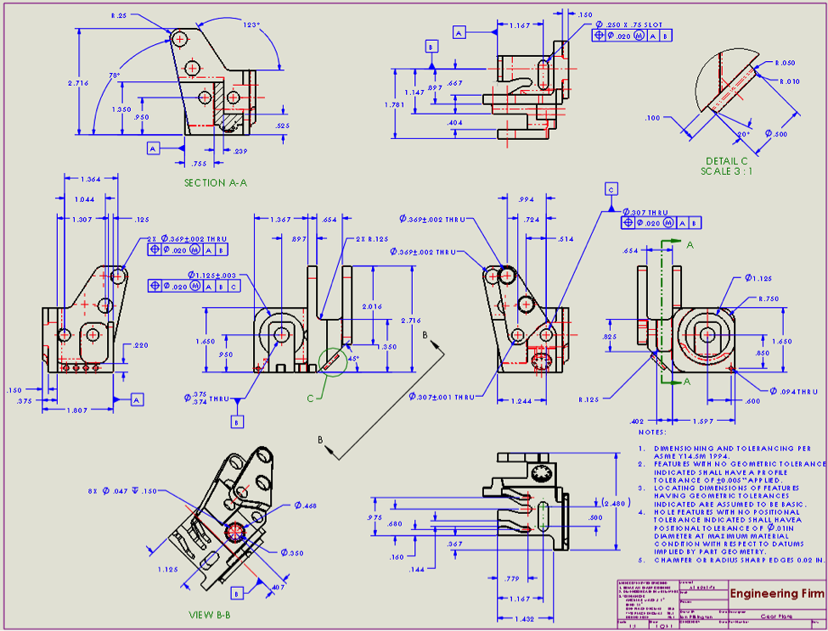
[This example drawing is a good representation of what should be included within your technical drawings.]
[Most of the design software packages will generate a number of different formats and as with the 3D files, check with the supplier to ensure you send the correct format.]
[However you transfer your files, ensure you provide the correct format for what is required. Also consult with your supplier with respect to what they need and can handle.]
List here all the file names you are sending so that they can be checked off by the supplier when they have downloaded them.
File Name | Part name and description | Revision

Test requirements
[The test requirements should be fully documented and generally added to a test plan template. Reference your test plan document number here so that the supplier can cross reference the test plan against the Design File Document.]

Certification Requirements
[The certification requirements should be fully documented and generally added to a test plan template. Reference your test plan document number here so that the supplier can cross reference the test plan against the Design File Document.]

Inspection Pass Criteria
[The test pass criteria should be fully documented and generally added to a test plan template. Reference your test plan document number here so that the supplier can cross reference the test plan against the Design File Document.]

